*FootyAI Intel*

**5.5 CREATE WBS PLAN**

Revision 4

*12/6/2023*

**VERSION HISTORY**

| **Version #** | **Implemented**  **By** | **Revision**  **Date** | **Approved**  **By** | **Approval**  **Date** | **Reason** |
| --- | --- | --- | --- | --- | --- |
| 1.0 | Eric Wnorowski | 10/16/2023 |  |  | Initial Risk Management Plan draft |
| 2.0 | *Eric Wnorowski* | *10/29/2023* |  |  | Updated accordingly with 5.15 Resource Management Plan |
| 3.0 | *Eric Wnorowski* | *11/12/2023* |  |  | Update accordingly with 5.24 Stakeholder Management Plan |
| 4.0 | *Eric Wnorowski* | *12/6/2023* |  |  | Final Revised Version |

**TABLE OF CONTENTS**

**1** **INTRODUCTION 1**

1.1 Purpose Of The project WBS 1

**2** **CREATE WBS PROCEDURE 1**

2.1 Process 1

2.2 WBS CREATION 1

2.3 DECOMPOSITION 2

2.3.1 Scope Baseline

2.3.2 WBS

2.3.3 Project Document Updates 4

**CREATE WBS PLAN APPROVAL 6**

**APPENDIX A: REFERENCES 7**

**APPENDIX B: KEY TERMS 8**

# **INTRODUCTION**

## **PURPOSE OF THE PROJECT WBS**

The WBS is a foundational building block to initiating, planning, executing, and monitoring and controlling processes that are used to manage projects as they are described in the *PMBOK® Guide.* The WBS is used as a starting point for scope management and is integral to other PMI processes, and, as a result, the standards that define these processes explicitly or implicitly rely on the WBS. The WBS is a deliverable-oriented hierarchical decomposition of the work to be executed by the project team to accomplish the project objectives and create the required deliverables. It organizes and defines the total scope of the project. Each descending level represents an increasingly detailed definition of the project work. The WBS is decomposed into work packages. The deliverable orientation of the hierarchy includes both internal and external deliverables.

This Create WBS Plan defines how work associated with the *FootyIntel AI* project will be identified, analyzed, and managed. It outlines how WBS management activities will be performed, recorded, and monitored throughout the lifecycle of the project and provides templates and practices for recording and prioritizing risks. The Create WBS Plan is created by the project manager (Eric Wnorowski) in the Planning Phase and is monitored and updated throughout the project. The intended audience of this document is the project team, project sponsor, product owner, executives, and stakeholders.

# **CREATE WBS PROCEDURE**

## **PROCESS**

In order to create the WBS process the project has been broken down into major work processes at level one at the WBS structure. There are two major components to this project, creating the model and then implementing it. These two components will be broken down into five level one processes - three for creating the project and two for implementing it. Through these five processes the WBS will be able to cover the totality of the work required to execute the project.

The project manager working with the project team and project sponsors will ensure that WBS is actively identified, analyzed, and managed throughout the life of the project. The steps for accomplishing this are outlined in the following sections. The Project Manager (Eric Wnorowski) will serve as the WBS Manager for this project.

## **WBS CREATION**

The project documents used to create the WBS process include but are not limited to:

* Project Scope statement – describes the work that will be performed and the work that is excluded.
* Requirements documentation – describes how individual requirements meet the business need for the project.

Other factors influencing the WBS:

* Enterprise environmental factors include football association regulations and laws that may affect the use of technology in football. The project will also need sufficient data to create the model, there should be sufficient access for this project.

Organizational process assets that can influence the Create WBS process but are not limited to:

* Policies, procedures, and templates for the WBS
* Project tools from previous AI projects done by the company
* Lessons learned from previous AI projects done by the company

Expertise should be considered from individuals or groups with knowledge of or experience with similar projects:

* The team will consult with data analytic experts currently in the football industry. These experts use data to provide insights in their specific team, which may provide context to the relevant data needed to create the project.
* Then utilize experts in data science and machine learning to find which models may be most effective for our project. Considering the project will utilize standard data in combination with video data it will be important to consult with experts in both fields to find which combination of models will be most effective.

## **DECOMPOSITION**

As mentioned previously there are two major components of the project which will be divided into five processes. These represent the major work processes needed to create the main functionality of the project. The processes will be decomposed into smaller work processes that will represent 100% of the work needed to create the project. The level of decomposition is often guided by the degree of control needed to effectively manage the project. The level of detail for work packages will vary with the size and complexity of the project. Decomposition of the total project work into work packages generally involves the following activities.

### **Scope Baseline**

The scope baseline is the approved version of a scope statement, WBS, and its associated WBS dictionary, which can be changed only through formal change control procedures and is used as a basis for comparison.

Project scope Statement: FootyIntel AI provides football clubs with an artificial intelligence model that can provide effective and successful tactical analysis in real time.

* + 1. **Work Breakdown Structure**

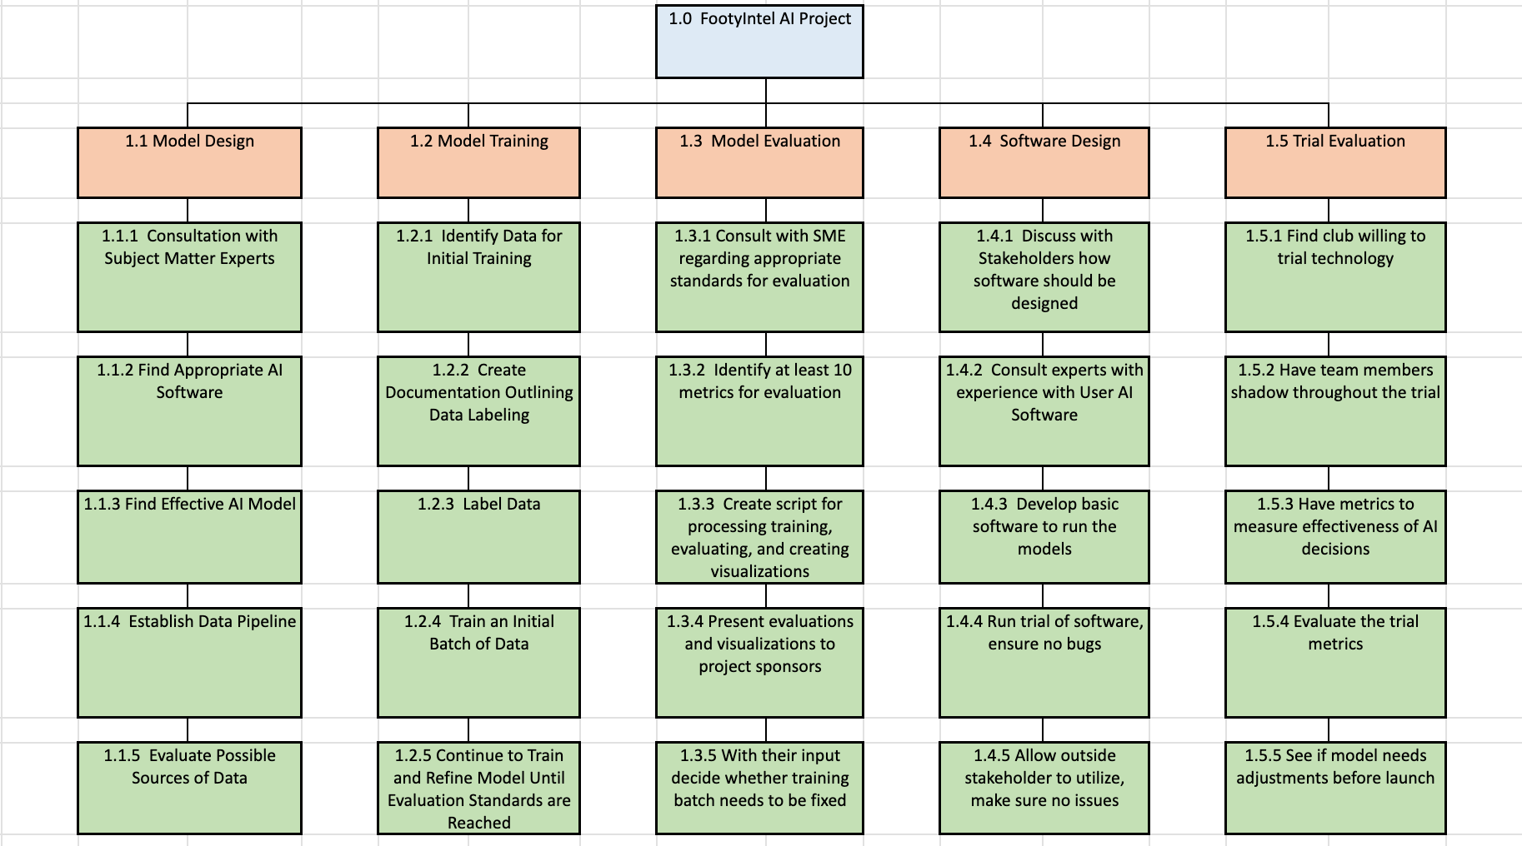

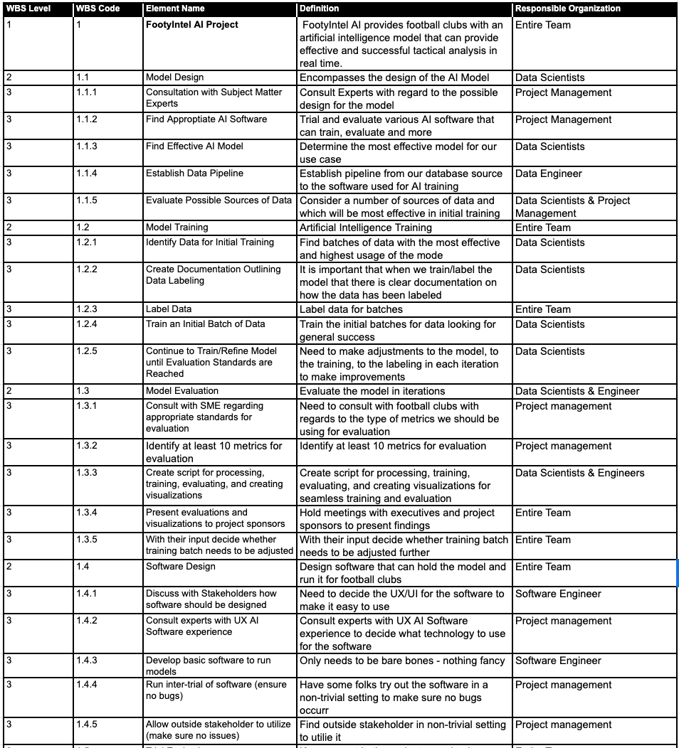

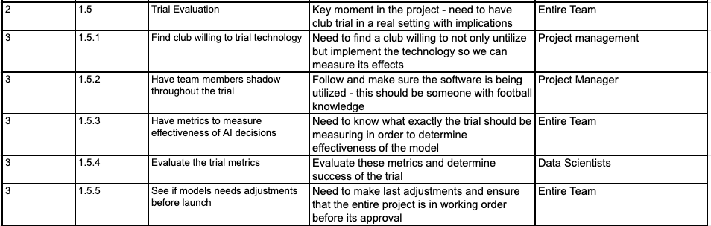

### **Project Document Updates**

* Assumptions log – updated with additional assumptions or constraints that were identified in the WBS process.
* 5.3 Collect Requirements Traceability Matrix - Updated to mark down the appropriate WBS Work Package Deliverables
* WBS Code 1.4.3 should specify that the software being developed will not be executed by the project team. Another software team within the FootyIntel firm will work with the project team to create the software.

CREATE WBS PLAN APPROVAL

The undersigned acknowledge they have reviewed the **Create WBS Plan** for the *FootyIntel AI* project. Changes to this Plan will be coordinated with and approved by the undersigned or their designated representatives.

| Signature: |  | Date: |  |
| --- | --- | --- | --- |
| Print Name: | Eric Wnorowski |  |  |
| Title: | Project Manager |  |  |
| Role: |  |  |  |

| Signature: |  | Date: |  |
| --- | --- | --- | --- |
| Print Name: |  |  |  |
| Title: | Product Owner |  |  |
| Role: | Project Sponsor |  |  |

| Signature: |  | Date: |  |
| --- | --- | --- | --- |
| Print Name: |  |  |  |
| Title: | Vice President of Artificial Intelligence |  |  |
| Role: | Project Sponsor |  |  |

| Signature: |  | Date: |  |
| --- | --- | --- | --- |
| Print Name: |  |  |  |
| Title: | Chief Technology Office |  |  |
| Role: | Project Executive |  |  |

**APPENDIX A: REFERENCES**

The following table summarizes the documents referenced in this document.

| **Document Name and Version** | **Description** | **Location** |
| --- | --- | --- |
| 4.1 Project Charter Plan | Project charter is issued by the Chief Technology Officer & Vice President of Artificial Intelligence Software. The document is written to ensure a common understanding between the project sponsors, the product owner, the project manager, the project team, and the key company stakeholders. | Google Drive Key Documents Folder |
| 5.3 Collect Requirements Plan | This Collect Requirements Plan defines how requirements associated with the *FootyIntel AI* project will be identified, analyzed, and managed. It outlines how collect requirements activities will be performed, recorded, and monitored throughout the lifecycle of the project and provides templates and practices for recording and prioritizing requirements. | Google Drive Key Documents Folder |
| 5.15 Resource Management Plan | This plan defines how resources associated with the *FootyIntel AI* project will be identified, analyzed, and managed. It outlines how resource management activities will be performed, recorded, and monitored throughout the lifecycle of the project and provides templates and practices for recording and prioritizing risks. | Google Drive Key Documents Folder |
| 5.24 Stakeholder Engagement Plan | Stakeholder Engagement Plan is the process of developing approaches to involve project stakeholders based on their needs, expectations, interests, and potential impact on the project. The key benefit is that it provides an actionable plan to interact effectively with stakeholders. | Google Drive Key Documents Folder |

**APPENDIX B: KEY TERMS**

The following table provides definitions for terms relevant to the Risk Management Plan.

| **Term** | **Definition** |
| --- | --- |
|  |  |
|  |  |
|  |  |